Peerie Oorick Books – Shetland Dialect Education Resource

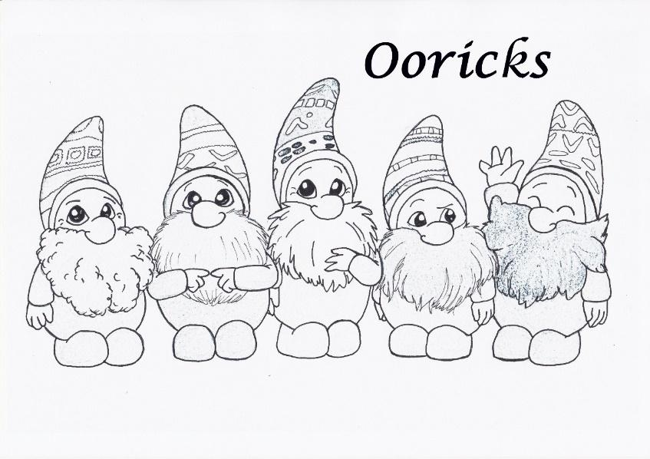
Introduction
For many years Shetland ForWirds have been promoting the use of Shetland dialect and creating teaching material for use in Shetland’s schools. This resource has been written to compliment a new series of books for young children published by ‘Peerie Oorick Books’.

Books covered in this resource:
- Da Ooricks by Ann Marie Anderson, illustrations by Jenny Duncan
- Ooricks in da Paet hill by Ann Marie Anderson, illustrations by Jenny Duncan
- Smoot da Oorick by Ann Marie Anderson, illustrations by Jenny Duncan
- Da Fisherman’s Wife by Ann Marie Anderson, illustrations by Jo Anderson

Copies of all these books should be in each school in Shetland. If not, copies can be borrowed through the school library.

This resource has been written with permission from the author and illustrators to use the books – both words and images – in schools to promote the Shetland dialect. If ELCs or schools would like an author visit from Ann Marie Anderson they can email her at: peerieoorickbooks@gmail.com.

This resource will introduce each book whilst exploring different themes and areas of the curriculum. Theme or Topics touched on in this resource include:
- the Shetland dialect
- Shetland’s history and previous generations
- local culture and heritage
- the sea
- climate change
- animals
- folklore
- traditions
- nature

We hope that the material in this resource can be used by teachers, either as one-off or standalone lessons, as part of a topic they are already studying where there are shared themes, or as part of a Shetland topic.

The lessons and activity ideas are linked to the Curriculum for Excellence, in particular, Literacy and Health and Wellbeing – both being areas which are a responsibility for all teachers – as well as 1+2 and Scotland’s programme for language learning across all ages and stages of the Broad General Education. If teaching the whole resource from start to finish there is progression from Early Years to First Level. We hope that you can adapt these lesson ideas, where necessary, to your own unique setting and classes. The experiences and outcomes listed for each set of activities is a guide, you will cover different Es&Os depending on how it fits with your learning programme.

A wird fae Ann Marie Anderson:

Da Ooricks originally started aff as bits o Shetland oo, which I needle felted in tae da characters ‘da Ooricks.’
Da wird oorick means nonsense, rubbish or a small person.
Da Fisherman’s wife wis also a needle felted character an I tought dat she also hed a peerie story tae tell as weel.
I noticed dat dir wisna ony Shetland dialect books fir peerie mootie eens, da eens dat wir available wir fir aalder bairns, so I saa a gap an tought I could fill it. So I started writin peerie rhymin stories aboot da needle felted characters. Da vibrant illustrations by Jenny Duncan & Jo Anderson brings each line o da poems tae life. You dunna hae tae understand da dialect as da illustrations explains whit’s goin on in da text.
Whin I veesit scöls an Early Years settings I notice dat da rhythmic rhyme an beat o dis peerie books captivate peerie listeners. Da bairns an teachers love hayin a go at pronouncin da dialect wirds an finnin oot whit da wirds means. Da use o props also help bring da books tae life; eg-
∙ a paet, clod or skyumpie
∙ oo
∙ a fair-isle garment
∙ musical instruments
I hoop dis resources provide a fun wye tae learn Shetland dialect wirds.
Ann Marie

Da Ooricks
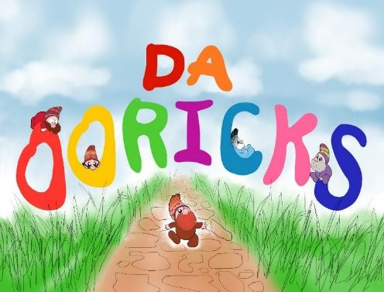

Whaar tae begin:
- Ask your class if they know what Shetland dialect is
  - Shetland dialect is the unique variety of Scots language used in the Shetland islands. It is distinctive because of strong links to Scandinavian languages which aren’t as common in other dialects of Scots used elsewhere.
  - Some Shetland dialect words regularly used today include peerie (small), bairn (child), breeks (trousers), gansey (jumper). This resource will teach you many, many more.
- Ask your class if they know anyone who speaks Shetland dialect
  - Many children themselves may speak some – and many may not be aware it is any different from English!
  - You might like to share this short video with your class

Read ‘Da Ooricks’:
- Read/listen to the story for enjoyment with your class (an audio recording of Ann Marie reading the story is available online)
- This book is written in Shetland dialect
  - Can everyone follow the story?
  - There is a word list and more info about Shetland dialect below
- As a class, discuss what different people liked or didn’t like about the story
- Speak about ooricks! What details are there in the story that tell us about who the ooricks are?

Shetland – English Word List for ‘Da Ooricks’
(many of these will be used again in the other books)
peerie – small
mootie – very small
fok – folk/people
bide – live
briggistanes – flat stones laid as a path leading in/out of a house
muckle – big
fin – find
hoid – hide
win – get
spang – leap
crӧ – crofting enclosure for working with sheep
oo – wool sheared from sheep
ganzies – jumpers
braaly – very
filsket – lively or high-spirited
foy – a party
hock – dig
rant – behave boisterously
gluff – frighten

Whit tae dӧ wance yir read da book an hed a yarn:
- Templates for colouring in ooricks are included below. A fun activity can be to give everyone in the class their own oorick sheet to colour and to also give their oorick a name. You can use the word lists in this resource to help with inspiration.
  - Ann Marie has used a dialect word as the name for 3 ooricks:
    - roosk - a big, strapping fellow
    - bulder - a loud noise, clumsy
    - smoot - to slink
- The templates also have Shetland dialect words on them.
  - Can the learner write a definition for the Shetland word?
  - Can each oorick also have a word that describes their character?
  - And can it be a Shetland dialect word?
  - Be creative and have fun!
- If you are going to read all the Peerie Ooricks Books included in this resource, now is a great time to start writing dialect dictionaries or dialect diaries with your classes.
- This could be done as a whole class, or, depending on the age and abilities of the class, learners could have their own individual dialect wordlist they can add to as you read more stories and learn more words.
- These wordlists will be very handy if you go on to do creative writing in dialect or want to evidence your learning from this topic.

Wan quick an aesy activity tae dӧ wi yer class is a wirdsearch:
* You can find larger, printer-friendly versions for using in class at the end of this document

Curriculum for Excellence – Experiences and Outcomes
I enjoy exploring and playing with the patterns and sounds of language, and can use what I learn.
LIT 0-01a / LIT 0-11a / LIT 0-20a
I enjoy exploring and choosing stories and other texts to watch, read or listen to, and can share my likes and dislikes.
LIT 0-01b / LIT 0-11b
I enjoy exploring events and characters in stories and other texts, sharing my thoughts in different ways.
LIT 0-01c

Ooricks in da Paet hill
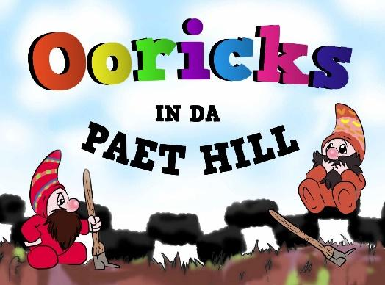

Whaar tae begin:
- Does everyone know what going to “da paet hill” means
  - The use of peat in homes across Shetland was once as common as having radiators in a house is now and going to the peat hill was a very important activity each year.
- Ask who has been to the peat hill
  - Some bairns may use peats at home on the fire? Some might have cut peats themselves?
- Here is a quick video on YouTube of two men working in da paet hill. Can everyone in the class understand what the men are doing and why?

Read ‘Ooricks in da Paet hill’:
- Read/listen to the story for enjoyment with your class (an audio recording of Ann Marie reading is available online)
- What did everyone like or dislike?
- There are lots of new Shetland dialect words to learn in this story:
  - gloor - faint light
  - mӧld - earth / mould
  - tushkar - spade designed for cutting peats
  - skyumpie - large mossy peat at the edge of the bank
  - “a paek” - long, slow job
  - swart - black
  - skreeds - lots
  - fantin - hungry
  - lowsed - loosened

Whit tae dӧ wance yir read da book an hed a yarn:
- One activity to try after reading ‘Ooricks in da Paet hill’ is to explore social studies and learn about ways of life from the past and how people used to live in Shetland.
- The way the ooricks live is very close to how people in Shetland used to live.
- What can we learn about life in Shetland from the details in the story?
- The ooricks, like the people who lived in Shetland in years gone by, are very tied to the natural environment around them. What can we learn about the natural environment around Shetland from the ooricks?

Facts fae da Paet Hill:
- Did you know around 12% of the United Kingdom is peatland?
- Over 20% of Scotland is made of peat soil and over half the area of Shetland is covered in peat, which has been accumulating at a rate of about 1mm a year for at least 3000 years.
- The UK's peatlands are a huge carbon store, with an estimated 3.2 billion tonnes of carbon locked up in the peat.
- It is important not only for the wildlife they support, but also for the ecosystem services that they can deliver such as carbon sequestration and storage, regulating water flow and purifying water.
- Most folk are aware of the importance of the rainforests in the carbon cycle on our planet but humble peatbogs actually store more than three times as much carbon as the rainforests and can help protect our planet from climate change.
- Healthy peatlands capture carbon dioxide (CO₂) from the atmosphere and so can help to offset the effects of human activities such as fossil fuel burning that are contributing to climate change.

For more info: https://www.shetlandamenity.org/peatland-restoration-project and https://www.ceh.ac.uk/news-and-media/news/human-activity-means-uk-peatlands-contribute-climate-change

Curriculum for Excellence – Experiences and Outcomes
* In addition to those listed above
To help me understand stories and other texts, I ask questions and link what I am learning with what I already know.
LIT 0-07a / LIT 0-16a / E NG 0-17a
I am aware that different types of evidence can help me to find out about the past.
SOC 0-01a
I have explored how people lived in the past and have used imaginative play to show how their lives were different from my own and the people around me.
SOC 0-04a
I explore and appreciate the wonder of nature within different environments and have played a part in caring for the environment.
SOC 0-08a

Smoot Da Oorick
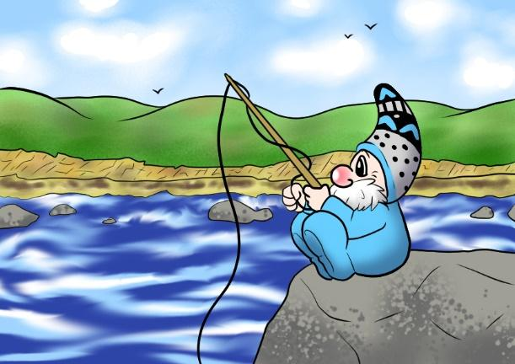

Whaar tae begin:
- From looking at the cover, ask your class what they think this story will be about? What is Smoot doing in the picture on the cover?
- Read the first two pages of the book. Stop when Smoot “recks fir his waand” what do we think will happen next?
- Ask the class if anyone has ever been fishing before. Perhaps some have been with a parent. Perhaps some in the class know people who work in the fishing.

Read ‘Smoot Da Oorick’:
- Read/listen to the whole story for enjoyment with your class (an audio recording of Ann Marie reading is available online)
- What did everyone like or dislike about the story? What new things have we learned about Shetland?
- There are lots of new Shetland dialect words to learn in this story
  - boolin - jumping
  - reck - reach
  - waand - fishing rod
  - platches - walk in a heavy-footed way through wet ground
  - ebb - the fore-shore
  - tang - seaweed
  - craigs - rocks along the fore-shore
  - drittlin - walking in a slow, laborious way
  - dook - dip
  - tirn - angry
  - collyshang - a noisy dispute
  - sharg - to nag
  - ricks - catches
  - banks-broo - cliff-edge
  - lipperin foo - full to the brim and overflowing
  - twartree - two or three
  - raans - the roe of a fish
  - stap - a Shetland dish where liver and soft parts of the head of a fish are mixed together

Whit tae dӧ wance yir read da book an hed a yarn:
- If you are doing a Topic on animals or things we find around Shetland, there is loads to explore using ‘Smoot Da Oorick’ and ‘Ooricks in da Paet hill’.
- Here is a list of animals mentioned in the stories:
  - sillock - coalfish
  - selkie - seal
  - draatsi - otter
  - bonxie - great skua
  - shalder - oyster catcher
  - tirrick - arctic tern
  - swaabie - black-backed herring gull
- When you read ‘Da Fisherman’s Wife’ you can add these animals to your list:
  - hen
  - coo
  - wirm
  - moose
- What other animals with Shetland dialect names can you add to the list? Does anyone in your class know which animals these are the Shetland names for:
  - grice
  - kye
  - kettlin
  - whalp
- You can find more animal names in dialect here as well as names for insects and other dialect lists. You might like to use these Flashcards Ann Marie has made with the names of Shetland animals:
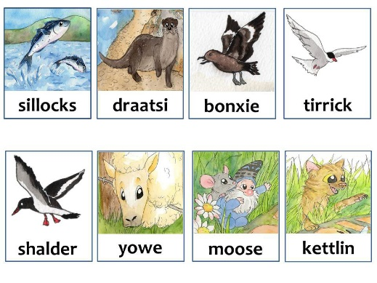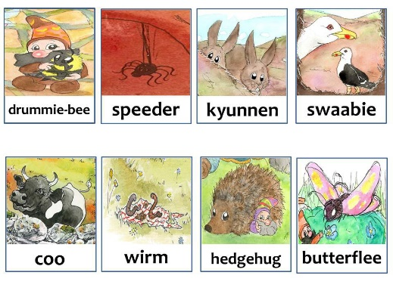
* larger, printer-friendly versions are available at the end of this document

Ann Marie’s ideas fir Creative Writing in Dialect:
- Imagine dat yir an Oorick an yir only 7 inches tall, if you wir an Oorick whit wid you do?
  - Whaar wid you bide?
  - Whit will you see?
- Wird lists fae da three books sae far can be used tae help bairns wi ideas an hoo tae spell wirds in dialect
- Shetland ForWirds Creative Writing Tips: https://www.shetlanddialect.org.uk/assets/files/tinder-box/files/creative-writing.pdf
- Shetland Wird list fae Education Scotland: https://education.gov.scot/improvement/learning-resources/100-key-scots-words/
- A great way to get started with creative writing is often to create a ‘Wanted’ poster for one of the characters
- Or you could imagine one of the characters in the books is missing. Working on their own or in pairs, learners could create a ‘Missing’ poster, adding all the details from the book they know and using them to try find who is missing...

Curriculum for Excellence – Experiences and Outcomes
I enjoy exploring events and characters in stories and other texts and I use what I learn to invent my own, sharing these with others in imaginative ways.
LIT 0-09b / LIT 0-31a
I enjoy exploring and playing with the patterns and sounds of language and can use what I learn.
LIT 0-01a / LIT 0-11a / LIT 0-20a
I enjoy creating texts of my choice and I regularly select subject, purpose, format and resources to suit the needs of my audience.
LIT 1-20a
I can write independently, use appropriate punctuation and order and link my sentences in a way that makes sense.
LIT 1-22a
Throughout the writing process, I can check that my writing makes sense.
LIT 1-23a

‘Da Fisherman’s Wife’
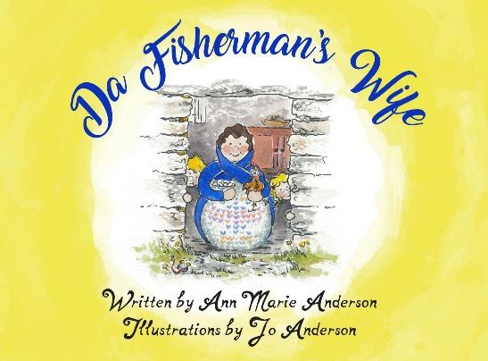

Whaar tae begin
- This story will be different from the books about ooricks you have read so far.
- From looking at the cover, what do those in the class think will be different in this story? For example, you may wish for children to establish that it isn’t about ooricks, it is about real people.
- What do we think will stay the same? For example, it will still be set in Shetland.
- Read the first two pages together. From looking at the illustrations, what can we tell about the characters in this story and where it is set? For example, this family live on a croft beside the sea.

Read ‘Da Fisherman’s Wife’
- Read/listen to the story for enjoyment with your class (an audio recording of Ann Marie reading is available online)
- What did everyone like or dislike about the story?
- What new things have we learned about Shetland?
- There are lots of new Shetland dialect words to learn in this story
  - skrits - hurries
  - but n ben - traditional two room Shetland croft house
  - reestit - smoke-dried
  - pell - a pale or bucket
  - baals - throws
  - kishie - straw basket
  - glaepin - gulping
  - reek - smoke
  - lem - crockery

Whit tae dӧ wance yir read da book:
- The story of the fisherman’s wife, like the stories about the ooricks, offers a glimpse into both a traditional Shetland family, and the role of a mother, parent or carer. One way to use ‘Da Fisherman’s Wife’ in a classroom setting is to read the story then discuss what we have learned about the character of the fisherman’s wife, then share what we know about people we look after, as well as those who look after us.
- Look at the illustrations on page three of the book with your class. Ask the children, what can we see the fisherman’s wife doing as she “skrits aroond fae but tae ben...” and why does the author write, “shӧ wid love a quiet life”?
- Making food and feeding children and animals is a big part of her day. Can the learners count how many times the fisherman’s wife feeds someone in the story...
- Once everyone and everything has been fed, the fisherman’s wife does the dishes and havers for a moment while she looks out the window. Who do the learners think is she looking for? There is a clue in the last line, “Langin fir her man at’s at da fishin, wissin dat he wis hame.” Does the class understand where he is and why?
- Sometimes the people we love cannot always be by our side. But as the back of the book shows, we all have to hope that some day soon the people we miss will come back again. Talk in class about what it is like to feel what the fisherman’s wife feels. What evidence can we find in the story for this?
- Who in the book might feel the same as the fisherman’s wife? Can we understand why? If it was the fisherman’s wife who was away from home, who would miss her? How can we help people who are upset because someone is not with them anymore?
- Talk about ways we can help to look after others. What ways are there today for keeping in touch with those who are far away?

Curriculum for Excellence – Experiences and Outcomes
I am aware of and able to express my feelings and am developing the ability to talk about them.
HWB 0-01a / HWB 1-01a
I know that we all experience a variety of thoughts and emotions that affect how we feel and behave and I am learning ways of managing them.
HWB 0-02a / HWB 1-02a
I know that friendship, caring, sharing, fairness, equality and love are important in building positive relationships. As I develop and value relationships, I care and show respect for myself and others.
HWB 0-05a / HWB 1-05a
I am learning skills and strategies which will support me in challenging times, particularly in relation to change and loss.
HWB 0-07a / HWB 1-07a

All learning materials and practitioner guidance in this resource has been written by and peer reviewed in partnership with Education Scotland.
Templates fir colourin in ooricks & idder activities

